**AWS Marketplace**

**AWS Marketplace**

[**AWS Marketplace**](https://aws.amazon.com/marketplace) is a digital catalog that includes thousands of software listings from independent software vendors. You can use AWS Marketplace to find, test, and buy software that runs on AWS.

For each listing in AWS Marketplace, you can access detailed information on pricing options, available support, and reviews from other AWS customers.

You can also explore software solutions by industry and use case. For example, suppose that your company is in the healthcare industry. In AWS Marketplace, you can review use cases that software helps you to address, such as implementing solutions to protect patient records or using machine learning models to analyze a patient’s medical history and predict possible health risks.

**AWS Marketplace Categories**

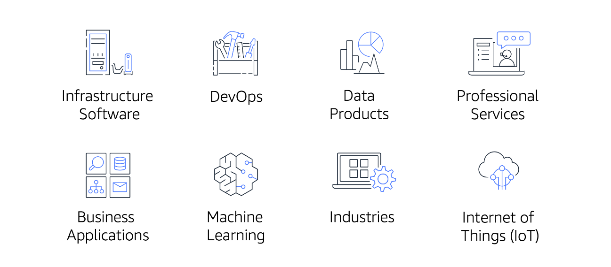

AWS Marketplace offers products in several categories, such as Infrastructure Software, DevOps, Data Products, Professional Services, Business Applications, Machine Learning, Industries, and Internet of Things (IoT).

Within each category, you can narrow your search by browsing through product listings in subcategories. For example, subcategories in the DevOps category include areas such as Application Development, Monitoring, and Testing.